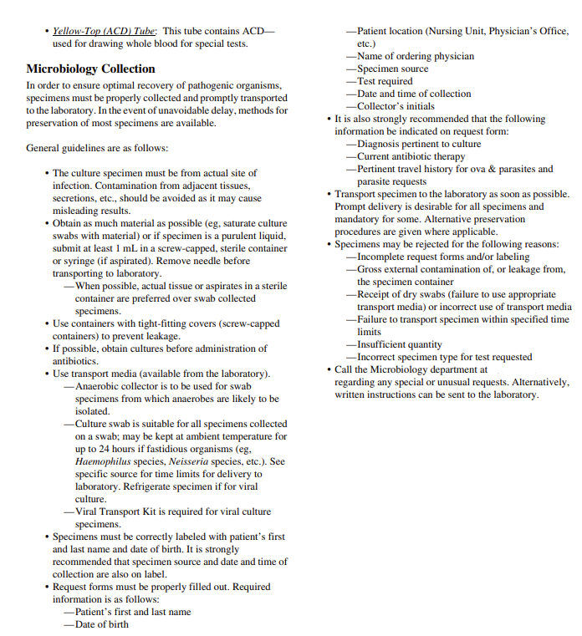

**207-626-6776**